Heating Curves Worksheet

Answer questions #1-12 using the following heating curve.

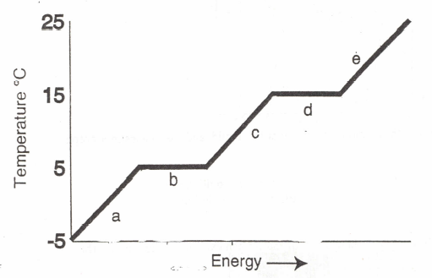

- What is the freezing point temperature of the substance? ______________
- What is the boiling point temperature of the substance? ______________
- What is the melting point temperature of the substance? ______________
- What letter represents the range where the solid is being warmed? ______________
- What letter represents the range where the vapor/gas is being warmed? ______________
- What letter represents the range where the liquid is being warmed? ______________
- What letter represents the melting of the solid? ______________
- What letter represents the vaporization of the liquid? ______________
- What letter(s) show a change in potential energy? ______________
- What letter(s) show a change in kinetic energy? ______________
- What letter represents condensation? ______________
- What letter represents freezing? ______________

Answer questions #13-24 using the following heating curve.

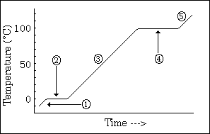

- What is the freezing point temperature of the substance? ___________
- What is the boiling point temperature of the substance? ___________
- What is the melting point temperature of the substance? ___________
- What number represents the range where the solid is being warmed? ___________
- What number represents the range where the vapor/gas is being warmed? ___________
- What number represents the range where the liquid is being warmed? ___________
- What number represents the melting of the solid? ___________
- What number represents the vaporization of the liquid? ___________
- What number(s) show a change in potential energy? ___________
- What number(s) show a change in kinetic energy? ___________
- What number represents condensation? ___________
- What number represents freezing? ___________

